Working with Lambda to stop an EC2 instance

1. Simple create and launch an EC2 instance.  
   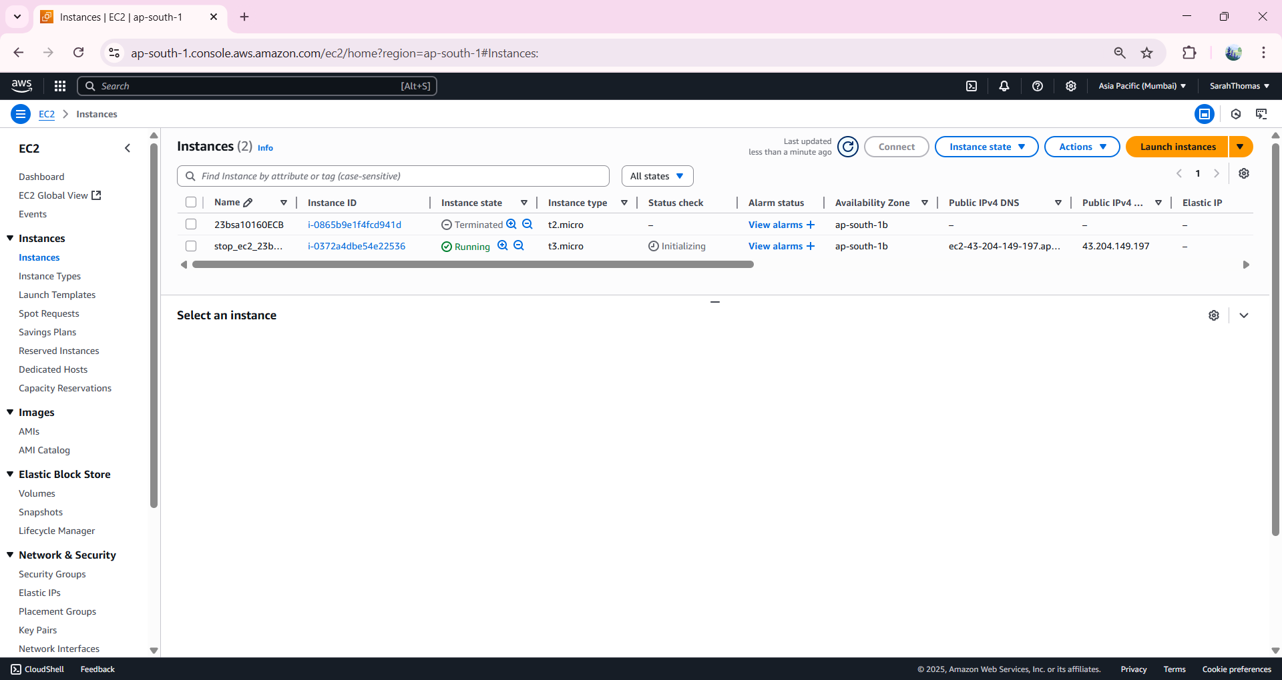
2. Open IAM from AWS console.  
   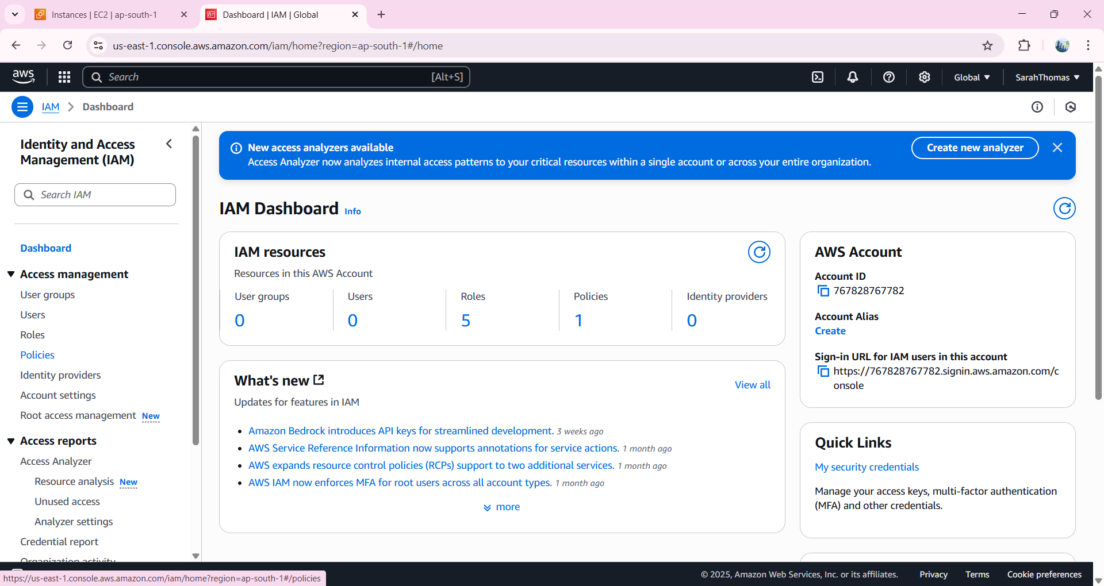
3. Navigate to Policies an.  
   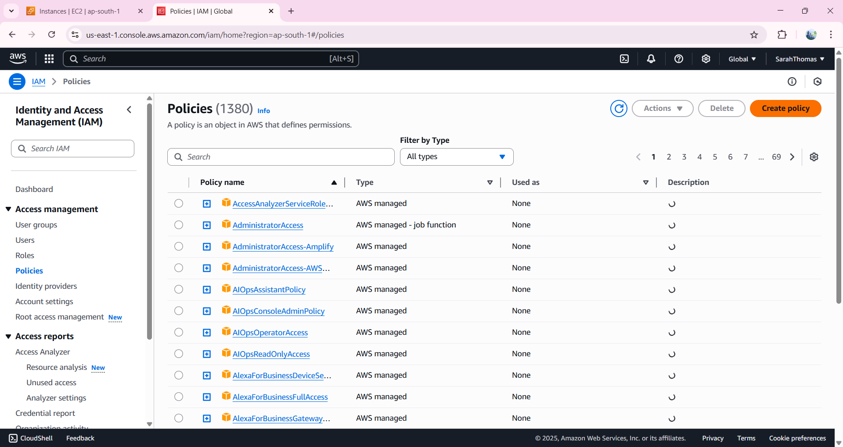
4. Choose service as EC2 -> Write -> StopInstances  
   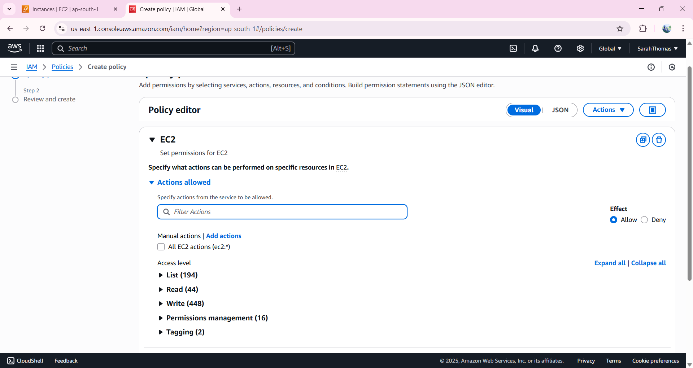

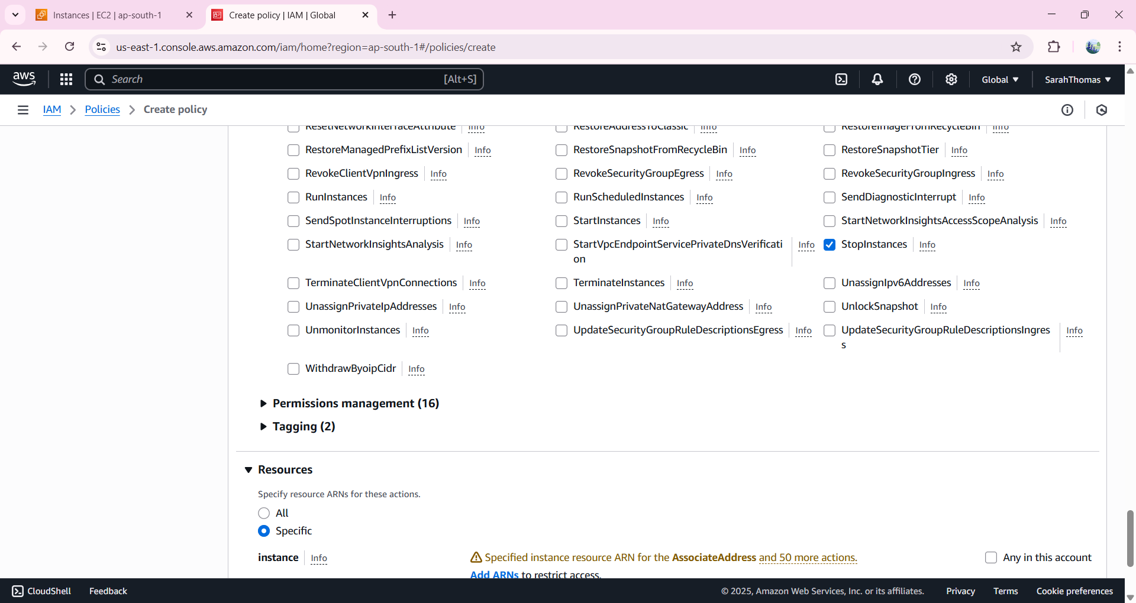

1. Click on Add ARN -> select This Account -> any region -> any instance -> add ARN.  
   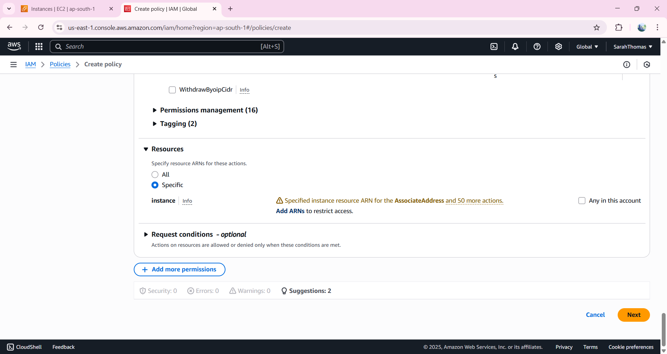  
     
   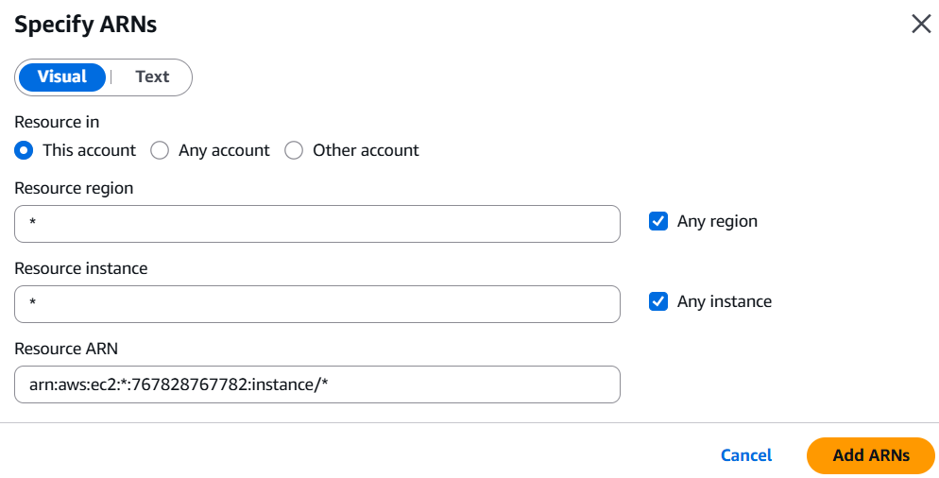
2. Click next.  
   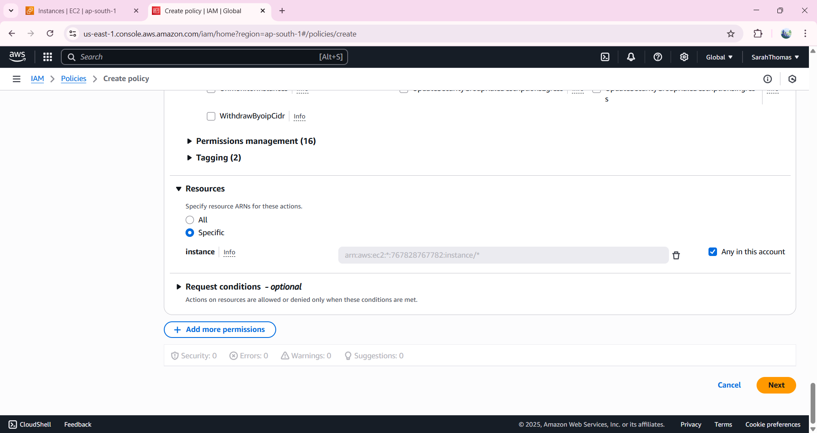
3. Give Policy name and description and then click on Create policy.  
   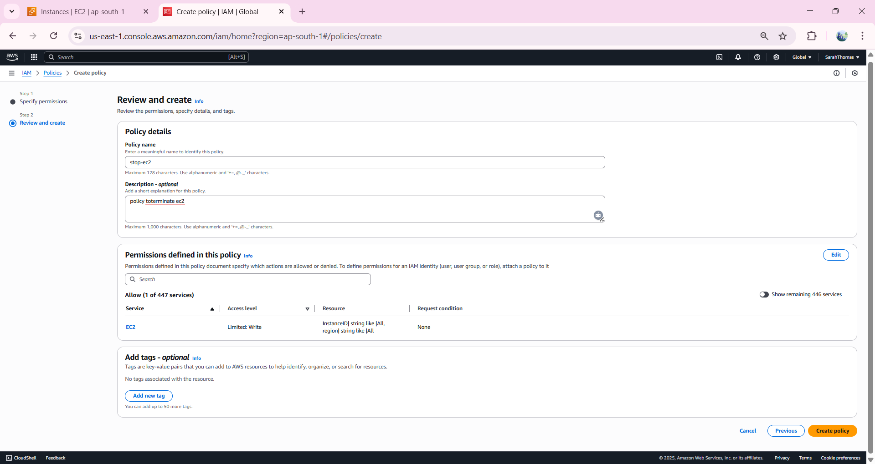
4. Navigate to Roles -> Create roles -> service = Lambda -> search for policy created, select and click next - > give role name and click on Create role.  
   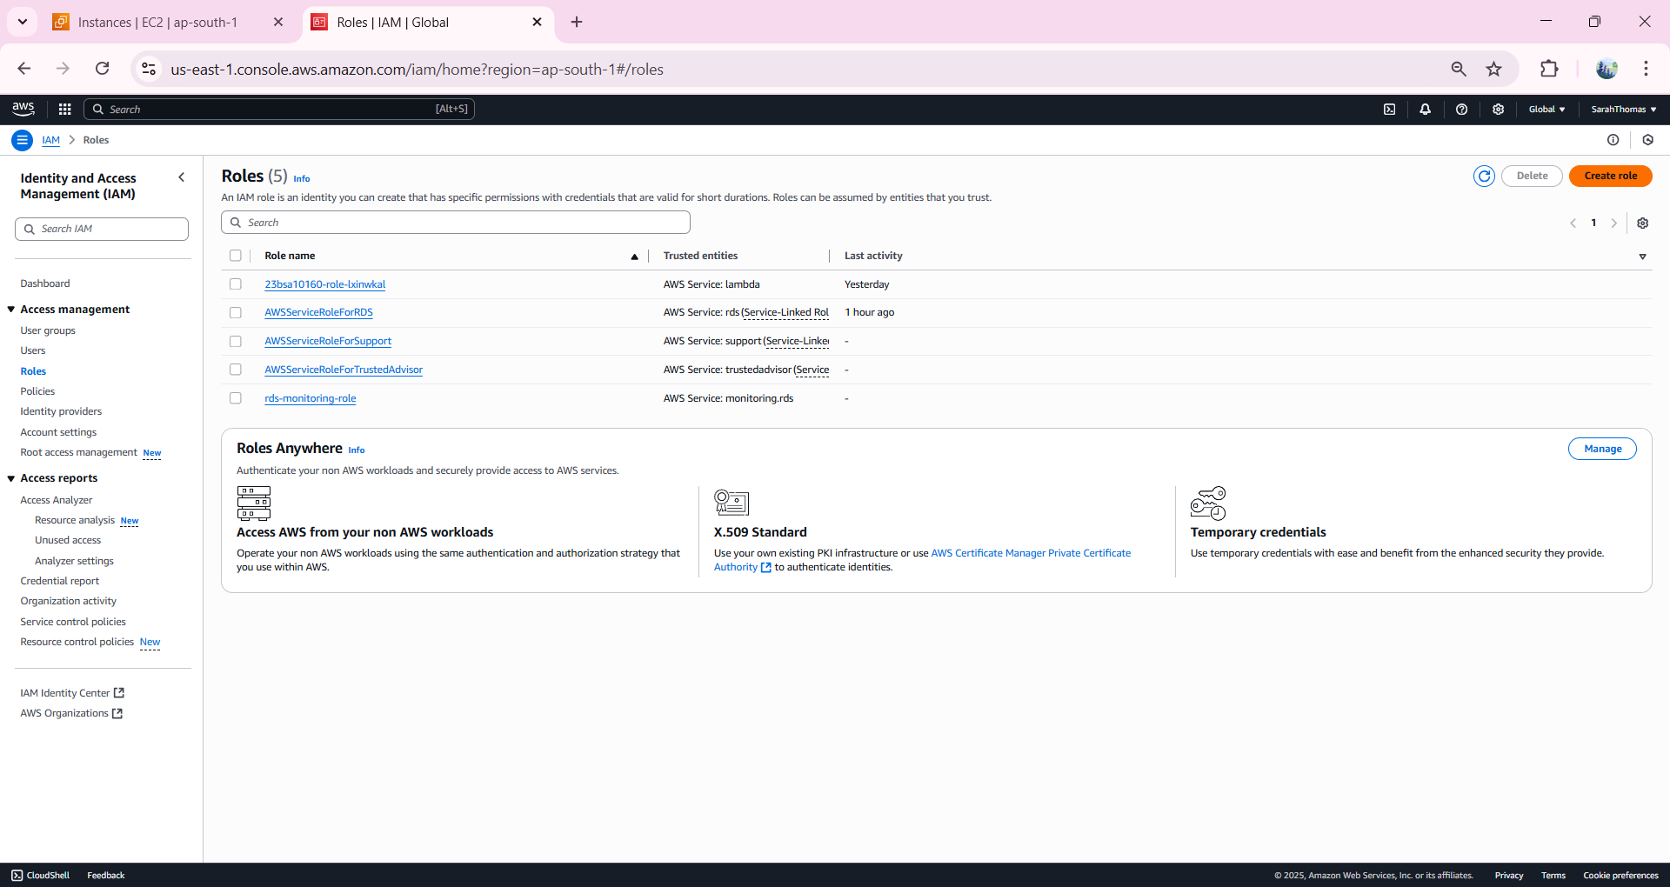  
     
   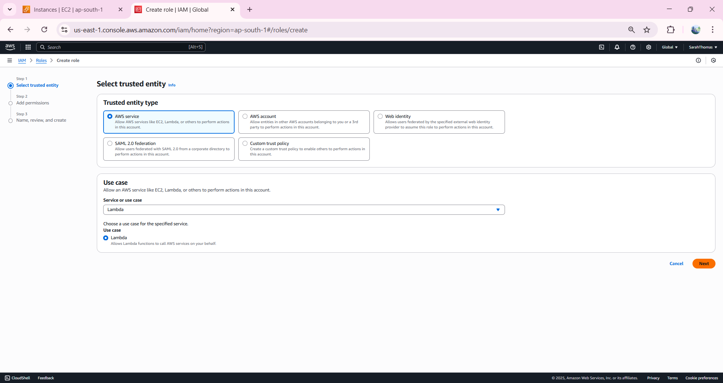  
     
   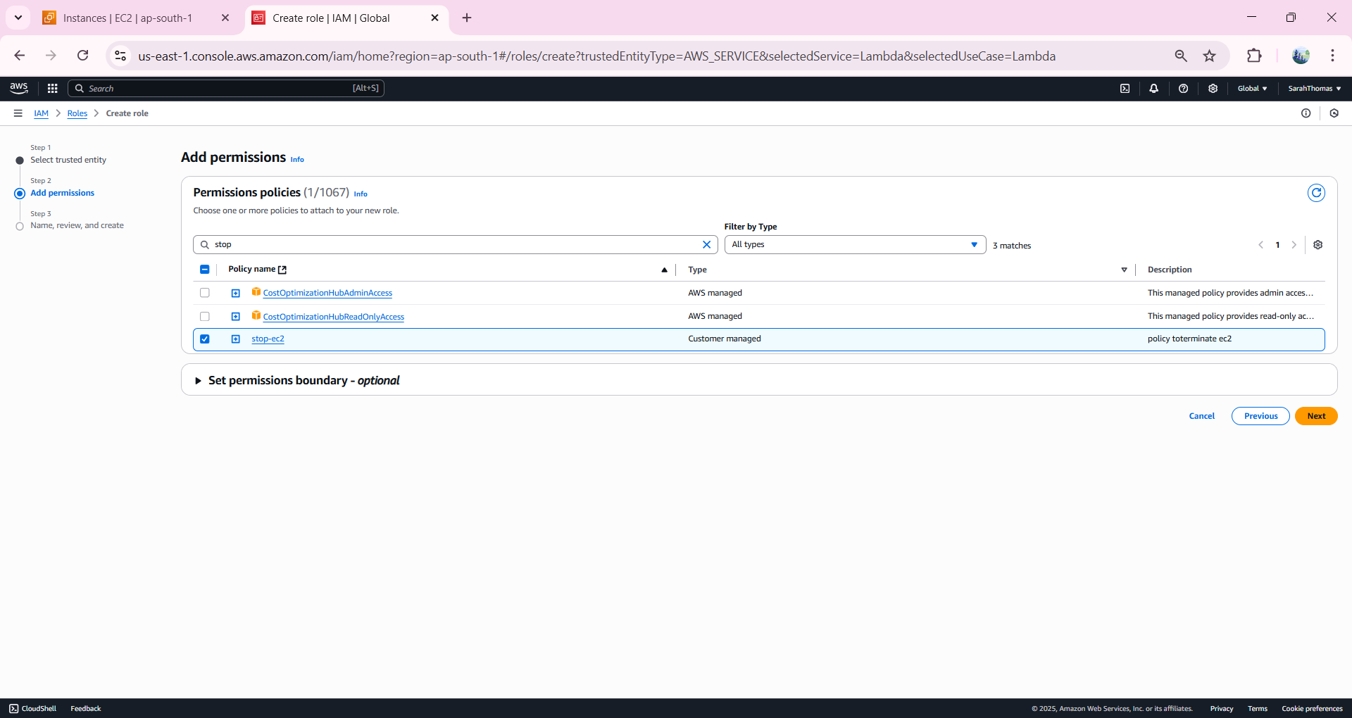
5. 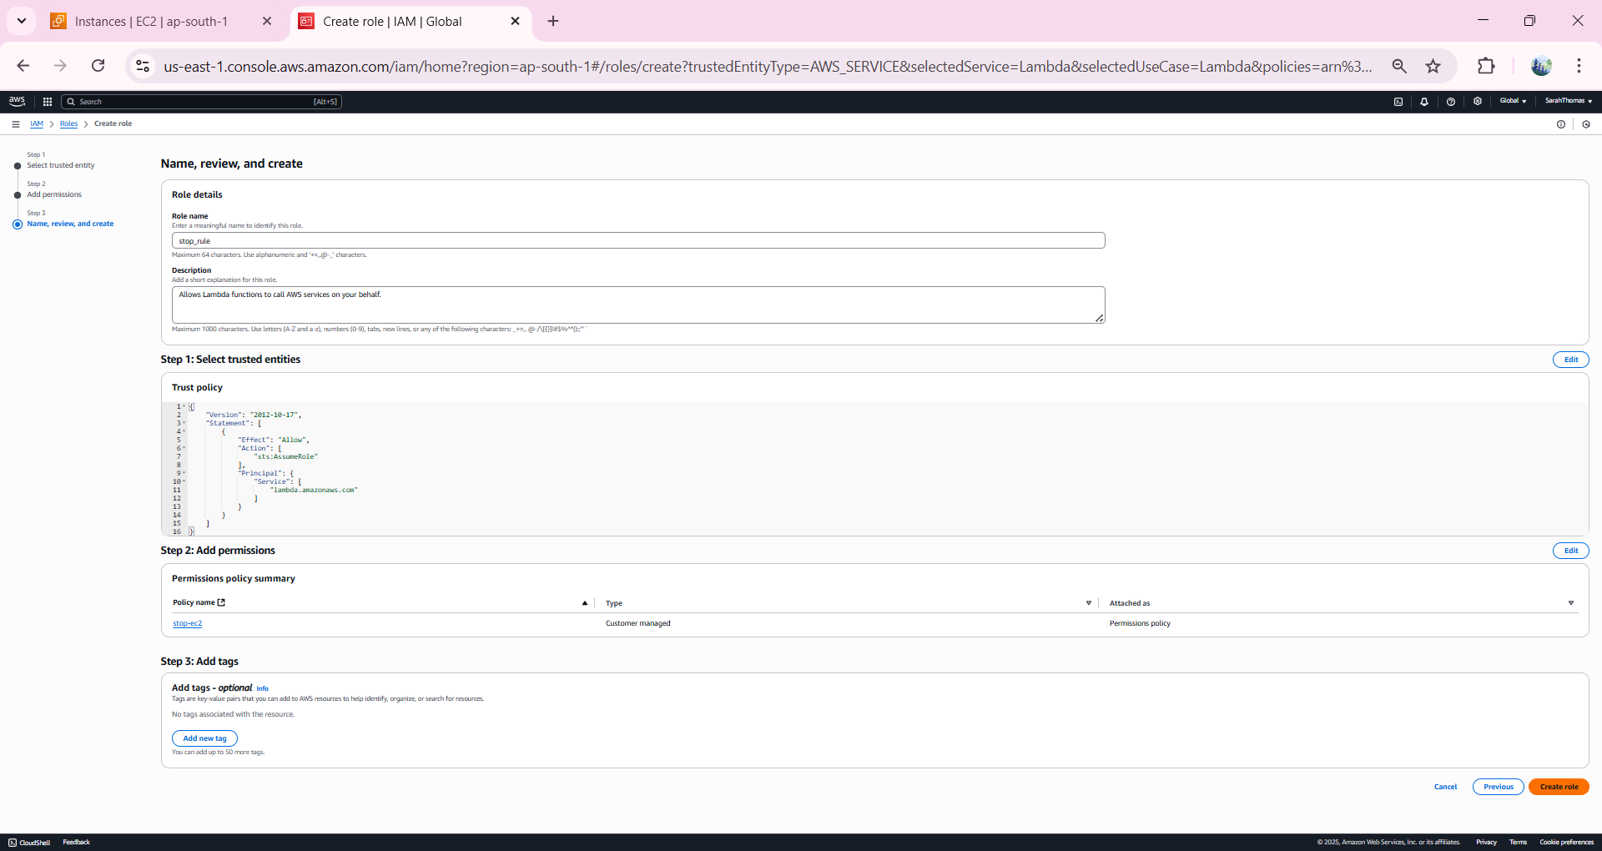
6. Open AWS Lambda -> Create Function.  
   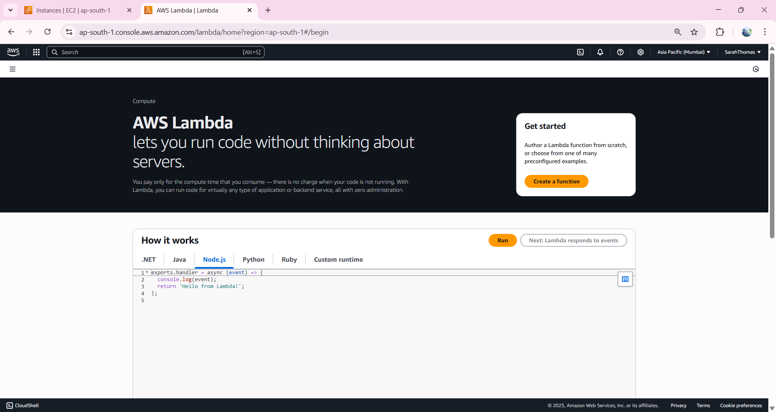
7. In Basic Info Section, give function name, runtime and under permissions choose existing policy and select the policy that we created earlier -> Create Function.  
   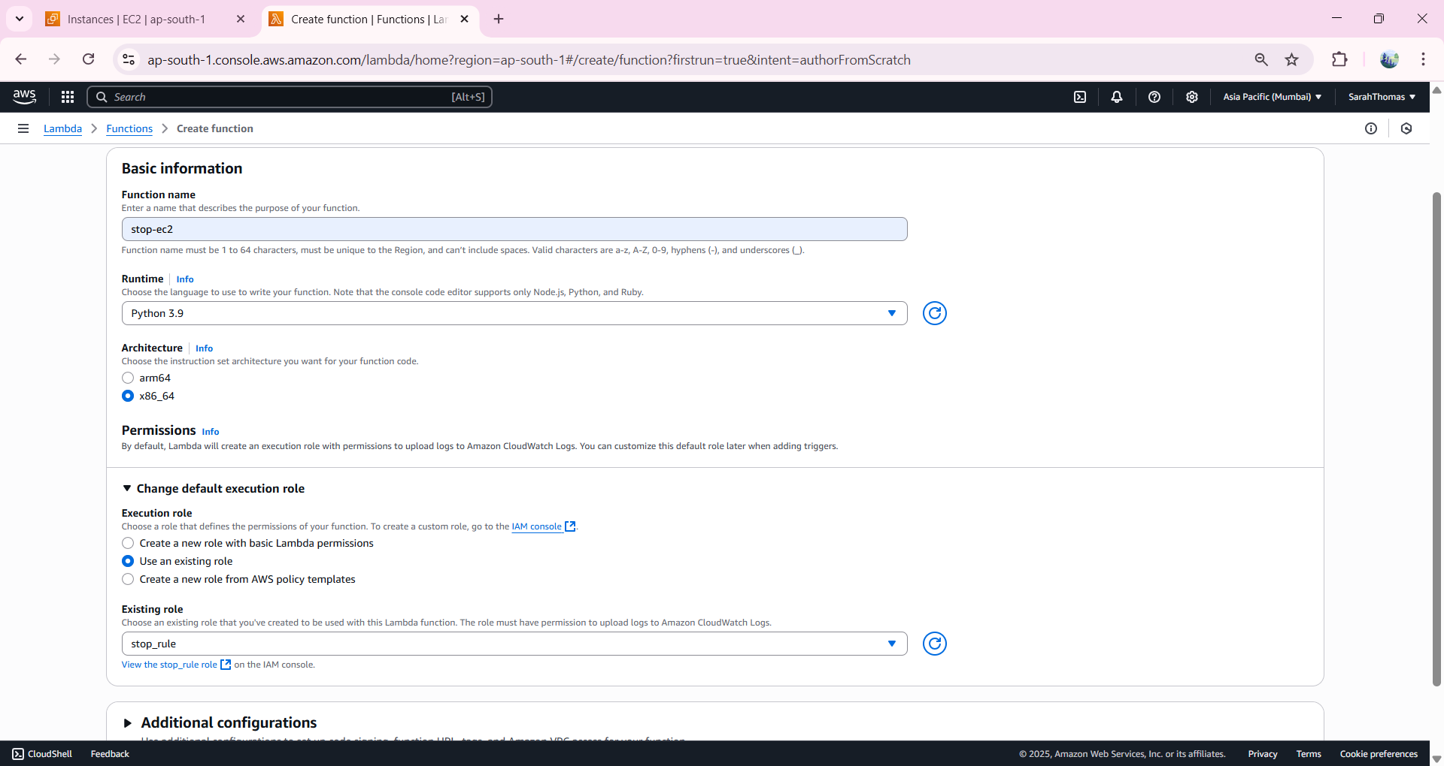
8. In the Code Source, insert Code to stop instance, but change the AZ and instance ID.  
   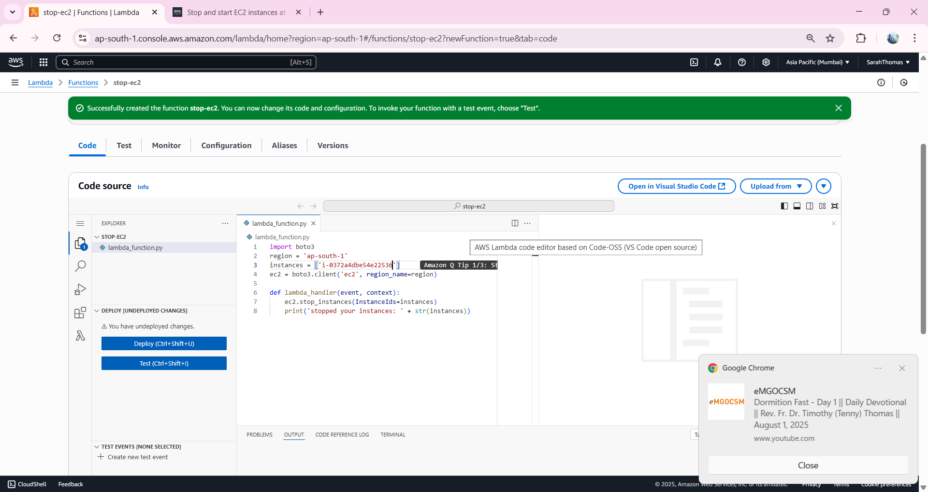
9. Then Deploy and Test the code, we will see that the instance is deleted.  
   